

|  |  |  |  |  |
| --- | --- | --- | --- | --- |
| Course Code: |  | DSA821S | Semester: | 2 |
| Course Title:  Lecturers: |  | Data Science and Analytics  Coordinators:  Primary: Dr Lameck Mbangula Amugongo | | |
| **STUDENT** | **Names** | **Roosa Shilomboleni & Alex Hawala** | | |
| **215075447 & 216001382** | | | |

**Faculty of Computing**

**and Informatics**

**Name of Department:**

**Informatics**

Contents

Abstract 3

Related work 3

Method 3

Results 4

Discission 5

Conclusion 5

Acknowledgment 5

References 6

# Abstract

Chatbot use is on the rise, and this is essentially changing how people engage with technological developments. By building a chatbot to respond to inquiries from students, applicants, and anyone else seeking information about the faculty and its programs, the Faculty of Computing and Informatics (FCI) is able to respond to the vast bulk of questions started receiving during the application and registration phases.

One of the benefits of a chatbot is that it can provide information to students, applications, and visitors at any time, this enables to complete many requests and boost customer satisfaction. Chatbots usually are unable to responded to enquiries that do need complex parts or a difficult judgment due to their small resilience.

# Introduction

Users can talk with digital devices as though they were chatting with a live agent thanks to the usage of chatbots, computer software that emulate and evaluate spoken and written human dialogue. Chatbots can range from simple programs that respond to a single instance to comprehensive virtual assistants that can learn from and improve as they gather and analyze data in order to enable increasing levels of personalization (BasuMallick, 2019). Organizations could save a lot of money and improve their effectiveness by leaning less on staff members and live operators.

# Related work

Inquiries about the application and registration processes are frequently directed to the Faculty of Computing and Informatics (FCI). These demands might occasionally be too much for the faculty to handle. FCI have decided to acquire for a chatbot to answer questions from students, potential candidates, and anybody else curious about the faculty and its programs. Instead of just answering, AI chatbots first establish what the user or customer is saying. Once the chatbot has discovered what the user is looking for, it will then reply with what it believes to be the appropriate response based on the facts at hand. The system gradually learns what is the "correct" response by examining both correct and incorrect responses.

# Method

The chatbot was created in a web-based application in which HTML, CSS and JavaScript were implemented. The FCI has asked for a chatbot that will provide students, applicants and visitors a better platform to engage with, without having to constantly contact admin to ask questions that could be easily answered remotely during the registration process. Notepad++ application was used to formulate the whole platform to meet all the requirement that FCI management has requested. It usually doesn't take long to deploy a chatbot. The bot must only be integrated with your full infrastructure and all endpoints must be connected.

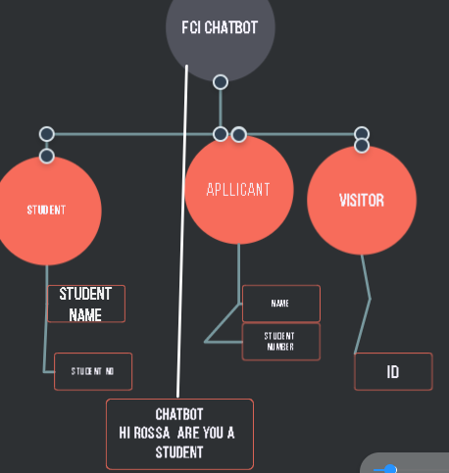

Figure 1

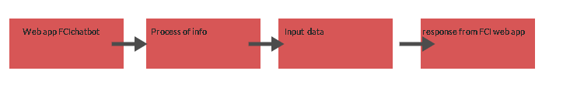

Figure 2

The two figures above show how the FCI Chatbot app is fully accessible by its users, outlining the logical flow of data in the application.

# Results

The chatbot has been built for a number of FCI programs, including the Ph.D. in computer science, Masters in computer science (informatics), Masters in data science, Honours, and Bachelor degrees. However, it has the capacity to manage a high number of queries and can offer details on these programs. Users can access the chatbot when they have been confirmed as students, applicants, or visitors. Students' student numbers and applicants' student numbers are used by both groups, while the visitors' special ID number serves as the chatbot's authentication key. The following in the screenshot a below is showing the chatbot in FCI webpage

. 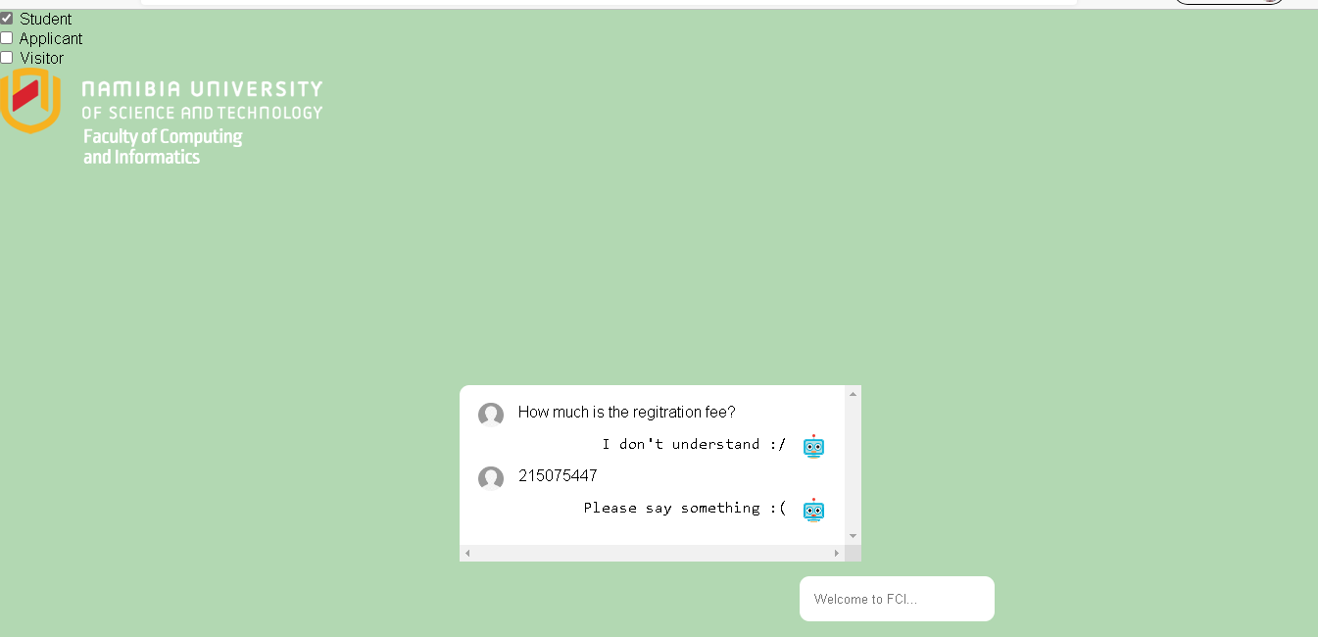

Figure 3

# Discission

The FCI chatbot is an interface for the user that are intended to further their studies at NUST. It has unique type of question that a user might ask and expect the answers at that moment. However not always all questions are valid to the system, incase chatbot mode cannot fully answer all questions incase some are invalid to the system because it was design in the sense that will only attend to the frequent asked questions. Every year, college employees waste a lot of time answering the same questions from freshman. A college guidebook is essential for first-year students to learn more about their institution. The perfect solution to that issue may be a chatbot for University-related questions.

# Conclusion

Chatbots may help students throughout the academic year, not only at the beginning. They may be used by colleges and institutions to keep students informed about tests, events, and the local community throughout the semester. Foreign students can access the portal at any time and utilize the college chatbots to ask questions about their student visas, options for paying fees, and academic issues (Hanaoka, 2022). When the chatbot is not available to answer a specific question from a student, they may establish a booking with their request, and a representative from the relevant department at the university will respond within a few of days.

As more and more colleges open their doors to foreign enrolment and student exchange programs, this simple but effective tool represents a huge step toward a tech-savvy and diverse community where every student feels at home.

# Acknowledgment

We would like to express our humble appreciation to Dr. Lameck Mbangula Amugongo for giving me this whole platform to help understand and formulate ideas for coming up with new techniques to mitigate obstacles. He made sure to prove his high oriented technology-driven processes for data analysis and the delivery of helpful information that helps executives, managers, and staff members in coming to wise business decisions. This has enabled us to understand aspects of mathematics and machine learning that were covered throughout this course. With his excellent technical background, we are now motivated by the many options to work in technology or even entrepreneurial professions, both of which are highly encouraged.

# References

BasuMallick, C. (2019). *A chatbot uses AI and automation to replace or augment human agents in customer service and engagement.* Chicago: Spice work.

Hanaoka, P. (2022, 07). *How universities are using chatbots to improve the student admissions process*. Retrieved from https://www.fullfabric.com/articles/how-universities-are-using-chatbots-to-improve-the-student-admissions-process: https://www.fullfabric.com/articles/how-universities-are-using-chatbots-to-improve-the-student-admissions-process